**Bitmap Indexes**

**1. Introduction**

* A **bitmap index** is a special type of indexing that maps attribute values to bit arrays.
* Particularly useful in **data warehouses** where read operations are frequent, and updates are minimal.
* **Comparison with B-Trees:**
  + Avoids **degenerated B-Trees** for low-cardinality attributes.
  + More efficient for **multi-dimensional** queries.
  + Supports complex **logical operations** (AND, OR, NOT) easily.

**2. Implementation**

* **Key Idea:** Instead of storing row IDs (TIDs) for each key value, it stores a bit vector.
* **Structure:**
  + Each **unique value** in the indexed column gets a **bitmap vector**.
  + **Bit = 1** → Row contains that value.
  + **Bit = 0** → Row does not contain that value.

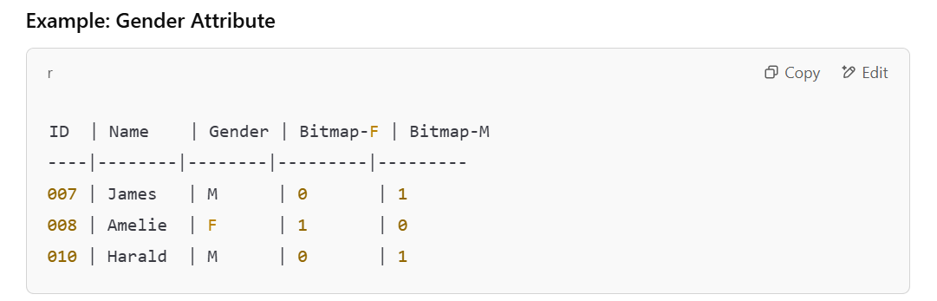

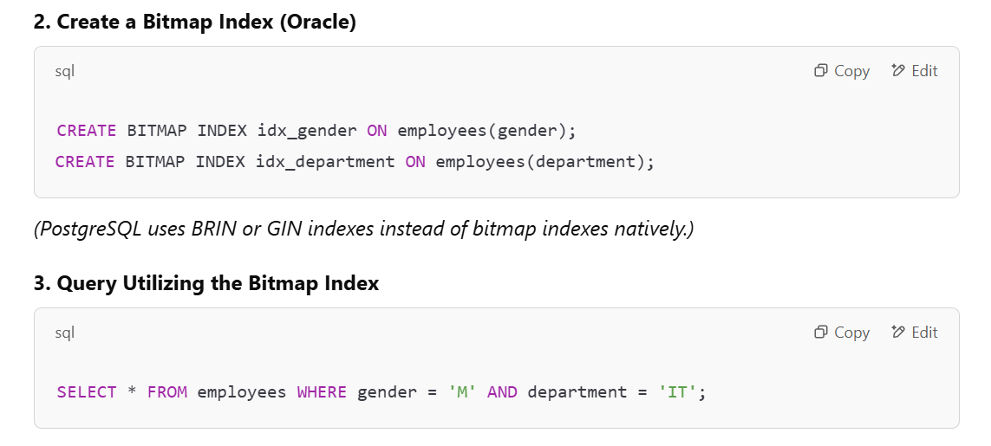

**3. Types of Bitmap Indexes**

**3.1 Standard Bitmap Index**

* Separate **bitmap vectors** for each attribute value.
* Each Dimension is stored separately
* **Efficient for queries** but **storage-intensive** when the number of unique values is high.